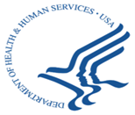
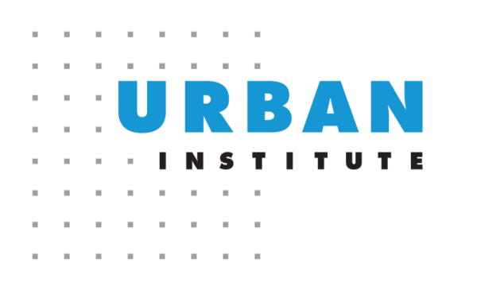

We want to hear from you!
We are researchers from the Urban Institute working with the US Department of Health and Human Services (HHS) to help them understand people’s experiences with issues like:

- Pollution or other bad air quality | - Weather that is too hot for comfort or health
- Lead in your home, workplace, or pipes | - Weather that is too cold for comfort or health
- Garbage or trash in your neighborhood | - Flooding or water damage in your neighborhood
- Storms or hurricanes | - Other bad things in the climate or environment

Have you experienced any of these problems?

We are offering a $50 Visa gift card for your participation in a virtual interview to share your experiences

- We will ask you questions about your experiences and any ideas or suggestions you have for HHS to help address these environmental and climate problems through human services programs.

- We will share the things you say with HHS but will not share your name or other information about you that would let them know who you are.

- You can choose to participate or not—it is not required—and you do not need to have personal experiences with all of these issues to participate. If you have experience with any of these environmental and climate problems, we may want to hear from you!

What: 30-45 minute interview

Where: Virtual by Zoom or phone (your preference)

When: In May, June, or July 2024

Who: Adults (18 and over) comfortable speaking English that have participated themselves or cared for others that participated in human services programs (like cash assistance, Head Start, child care subsidies, youth supports, programs for people with disabilities) in the last 5 years.

Please text, email, or call to ask any questions and discuss eligibility and scheduling if you would like to participate!
Mikaela Tajo, MTajo@urban.org, (202)261-5741

